**Week 01 Homework - Using the Web Inspector in Common Browsers**

Modern browsers will show you the CSS “box model” for any page they can display. To see the boxes, plus computed styles, you have to invoke the Console object.

**Getting to the CSS Inspector**

* In your browser (Google chrome, Mozilla Firefox, Internet Explorer (+)
* Right click on webpage
* Select Inspect Element, bringing up the Console object
* Click on the “Inspector” tab
* To change the element your are inspecting, click on the corresponding markup in the “Inspector” tab window

**Special Note for Safari**

By default, Safari hides its Console in a Developer Tools option, not set to default. To enable Developer tools in Safari:

1. Open Safari->Preferences menu at the upper-left of the Mac’s screen
2. Select the “Advanced” icon (gear at right)
3. Find the checkbox at the bottom of the Advanced screen, and check it
4. A new menu, “Develop” will appear in Safari’s menu bar at the top of the screen

**Seeing the Boxes**

* **Google Chrome**
* Click on the “Elements” tab on the upper left
* Highlighting of the element in the browser window is enabled by default
* To explore how the screen will look in different devices, select the “responsive design” icon to left of the upper-left tabs

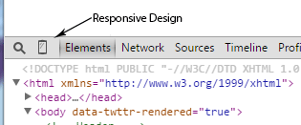

* **Firefox**
  1. Click on the “Inspector” tab on the upper left
  2. To highlight the selected element in the browser window, select the “gear” icon and Inspector -> Show Browser Styles
  3. To see computed styles, select the “Computed” tab on the right
  4. To see the visual “box model” select the “Box Model tab on the right
  5. To explore how the screen will look on different devices, click on the “responsive design icon” above the right-hand tabs

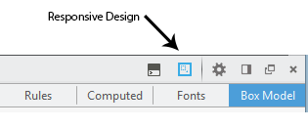

* **Internet Explorer**
  1. Select “DOM Inspector” at upper left
  2. To highlight selected elements in the browser window, select the highlight tool at upper left

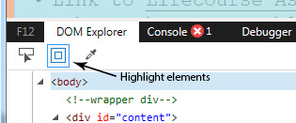

* 1. To see computed styles, select the “Computed” tab on the right
  2. To see the visual box model, select, “Layout” tab on the right
  3. To test your page in old versions of IE, select the versions tool

